
Amazon Interview Worksheet
Learn and Be Curious
Definition and Indicators
Learn and Be Curious: Leaders are never done learning and always seek to improve themselves. They are curious about new possibilities and act to explore them.
What this looks like in Practice
As a people manager do you… | As an individual contributor do you…
- Give your team members time to explore and learn?  - Encourage your team members to take risks and support them in doing so?  - Focus on how you arrived at the results rather than the results themselves?  - Encourage rotations to provide new opportunities for your team members to learn new skills? | - Take time to read, watch a tech talk, or actively mentor someone else?  - Ask your peers, manager, and customers for feedback on your performance?  - Pick up work outside your area of expertise to stretch and grow?  - Take time to understand your systems end to end?  - Actively seek out advice from others?

Learn and Be Curious - Suggested Behavioral Interview Questions
For each question you choose, use a separate STAR Worksheet
Questions for (Manager) in parentheses

- What is the coolest thing you have learned on your own that has helped you better perform your job?
- Tell me about a time when you realized you needed to have a deeper level of subject matter expertise to do your job well?
- When we enter into a new role or problem space, it is common to come in and see things with a fresh perspective. Tell me about a time when you realized that you might have lost that fresh perspective? What ended up happening?
- Tell me of a time when you took on work outside of your comfort area and found it rewarding?
- Tell me about a time when you didn’t know what to do next or how to solve a challenging problem?
- Example of a time when you pushed the existing boundaries beyond what was normal and expected for your space and you explored new territory?
- How have you kept up to date with market and competitor trends, and used that information to improve your company’s products / services?
- Give me an example of a time when you challenged the notion that something had to be done a certain way because it had always been done that way?
- What are you working on to improve your overall effectiveness at work?
- Tell me about a time when you challenged your team to push the envelope and go beyond existing standards and expectations. (Manager)
- Give a specific example of where you realized your team had not been as effective as it could have. What feedback mechanisms do you use? (Manager)
- Example when someone on your team challenged you to think differently about a problem? What was the situation, how did you respond? (Manager)
- Example where your team was unable to achieve a goal or milestone but the information gathered during the project enabled future success. (Manager)
- Tell me about a time when a member of your team contributed significantly to a project outside the scope of their role. What motivated you to encourage their participation? (Manager)

Background
Reasoning for new LP:
We are in a rapidly changing business environment - in order to stay nimble, people themselves have to be intellectually nimble. This nimbleness was implied in portions of Invent and Simplify, Vocally Self Critical, Earn Trust of Others, and Dive Deep. Listing Learn and Be Curious as its own principle elevates and clarifies the critical roles that learning, self-development, and curiosity play in being a successful leader and strong Amazonian.

Things to consider for a deeper understanding:
Listening to and responding to feedback
- Who are you asking for feedback from?
  - Who can provide honest, candid feedback without fear of hurt feelings or reprisal?
  - Are your team members willing to challenge your assumptions?
- Are you sincere in your request for feedback?
  - Do you plan on making changes to your processes or behaviors as a result of what you hear?
  - Are you merely trying to appease or asking for appearance’s sake?
  - Will the person who provided feedback see that it’s been taken into consideration?
  - Are you actually interested in learning about how you show up to others?
- How do you respond to criticism and negative feedback?
  - Do you listen first and respond later?
  - Are you rationalizing or explaining your behavior?
  - Do you argue back or take time to think about the feedback?
  - Do you ignore the feedback because of the person delivering it?
  - Do you find yourself getting defensive or emotional?
- How do you respond to vague or confusing feedback?
  - Do you follow up with specific questions like, “Can you give me an example?”
  - Do you ask for clarification if you don’t understand the feedback?
  - Do you ask for specific examples of behavior that could be improved or doubled down on?
- What are you doing with the feedback you do receive?
  - If the feedback triggered anger or other emotions, are you waiting till you’ve calmed down to evaluate the feedback?
  - Are you making changes to the way you interact with others or do your job based on the feedback?
  - Are you stopping to evaluate the element of truth that may be in harsh feedback?
- What do you do with conflicting pieces of feedback?
  - Which feedback do you want to follow up on?
  - Are there people you need to reach out to for clarification or for help in making a change?
  - Are you taking time to reconcile and synthesize conflicting pieces of feedback?
  - How is the individual’s role or perspective impact the view they have of you?

Experimenting and Handling mistakes
- How often are you trying new things?
  - When is the last time you made a mistake in your job?
  - When is the last time you had to do research to solve a problem?
  - When is the last time you took a risk?
  - Have you taken time to practice a new skill?
- Are you exercising curiosity in your current work?
  - Do you actually know how all of the parts of the system work?
  - What parts of your system would you change, and why?
  - How long have you been using your current tools and processes?
  - Do you have any experiments planned to change part of your tools or processes?
  - How could you restructure your work to allow for experimentation?
- What things could you learn from this mistake?
  - Do you understand the steps you took to get here?
  - Do you have a clear perspective on the parts played by others?
  - Do you have a good view of the environment?
  - What things didn’t you do that you could have?
  - How can you change your approach to get a different outcome?
- Are you focusing on the fact that you made an error, or on how to improve?
  - Are you blaming others for the outcome, or seeing what part you played?
  - Have you figured out how not to make the same mistake again?
  - Did you fill out the COE to check the box or to learn and improve?
Be intentional about your self-development
- What’s the last new thing you learned?
  - Have you watched a TED talk or POA broadcast video recently?
  - What new books are you reading?
  - What topics could you teach to your peers and your community?
  - How can you incorporate what you’ve learned back into your team, your product, or the way you interact with your customers?
- When is the last time you intentionally took on something that’s outside of your comfort zone?
- Can you clearly identify your strengths and weaknesses?
  - What are you doing to mitigate or work to improve your weak areas?
  - How are you doubling down on your strengths?
- What do you do when you encounter something you don’t understand well?
  - Is there a book you could read, a conference you could attend, or a class you could take?
  - Is there someone you could talk to at work that knows more about the subject?
  - What resources do your colleagues recommend?
  - Do you have a good place to practice new skills?
STAR WORKSHEET

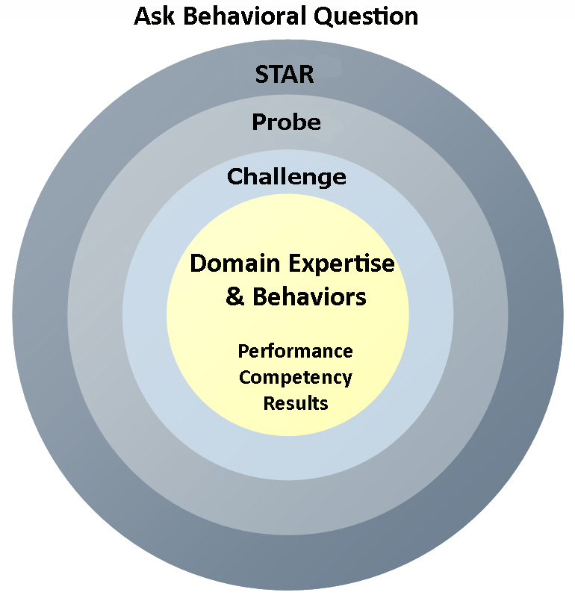
Your Behavioral Question:___________________________________________________________________Leadership Principle:_________________

- Choose behavioral question that provoke specific examples or stories for your assigned Leadership Principle(s).
- Process the example using STAR. Stories have beginnings (Situation/Task), middles (Actions) and ends (Results).
- Once you have established the story, PROBE to dive deeper on your assigned competency (Leadership Principle), get clarity or pursue a concern.
- If appropriate, CHALLENGE the candidate’s statements, decisions or thought process.
S  T | SITUATION/TASK - Describe the situation/task you faced and the context of the story  Answers the questions: where did this occur, when did it happen, why is it important?  Probing Questions:  - Why is this important? What was the goal?  - What was the initial scope of the project? What were the challenges?  - What were the risks and potential consequences if nothing happened?  Challenge Questions:  - Why did you choose this story to illustrate a xyz accomplishment?  - What other stories can you think of that demonstrate.. xyz?  - Could you come up with an example that is more recent? | Notes
A | ACTION - What actions did you take?  Answers the questions: what did you personally own, how did you do it, who else was involved?  Probing Questions:  - Deep probe functional expertise and/or assigned core competency.  - Were you the key driver or project owner?  - What was your biggest contribution? What unique value did you bring?  - What were the most significant obstacles you faced? How did you overcome them?  Challenge Questions:  - What did you do specifically versus the team?  - How did you set priorities…deal with xyz problem… or get manager buy-in?  - What decisions did you challenge? Why? How did you influence the right outcome?
R | RESULTS - How did you measure success for this project? What results did you achieve?  $ Cost savings, revenue generation  # Quantify to understand volume, size, scale  % Percentage change, year over year improvements  Time to market, implementation time, time savings  Impact on the customer, the team  δ Quality improvements  Probing Questions:  - Why did you choose to focus on these results? What other results were important?  - You mentioned revenue, what percentage change is that year over year?  - What trade-offs did you have to make to achieve this? (quality, cost, time)  - I’m concerned about… (the time it took, the volume, the customer impact), tell me more…  Challenge Questions:  - What were the lessons learned? What would you have done differently?  - How would you implement this at Amazon?  - How did these results compare to your actual goals? (refer back to goal stated in Situation)

